# **Software Requirement Specification**

# **For**

# **Hotel Management System**

Submitted by

Ankit Kumar (55)

Varun Maddi(56)

Anushka Mahajan(57)

### **1. Introduction**

#### **1.1 Purpose**

The purpose of this document is to define the software requirements for the Hotel Management System (HMS). The HMS is designed to automate hotel operations such as reservations, check-ins, check-outs, billing, room management, and customer relationship management.

**1.2 Scope of the Project**

The HMS project is intended for the reservations for rooms that can be made through online. It will be able to automate the various operations of the Hotel.Our Hotel Management System will have three end users: Customer, Receptionist, and Hotel Manager. Hotel Management System will consists of Booking Management System, DBMS Server, and Report Generator.Customers will be able to check for room’s availability, select the rooms, and pay for the room. Receptionist will have access to update or modify booking details. Manager will able to view the financial report and able to update room information such as cost and category. The main goal of this introduced automated HMS software is to simplify every day process of hotel. Day to day Hotels are increasing and they need to automate to provide customer ease of access. It will be able to take care of services to customer in a quick manner. This automation will be able to replace the drawbacks of large customer information physical files which were difficult to handle. Secure Transaction, quick retrieval of information, ease of use, quick recovery of errors,fault tolerance are some of the benefits that the development team will be working on to achieve end user satisfaction.

**1.3 References**

* Software Engineering 9 th Edition, Ian Sommerville
* Mohapatra, H., & Rath, A. K. (2020). Fundamentals of software engineering: designed o provide an insight into the software engineering concepts. BPB Publications.

**1.3 Definitions, Acronyms, and Abbreviations**

* HMS: Hotel Management System
* GUI: Graphical User Interface
* API: Application Programming Interface
* DBMS: Database Management System

**1.4 Overview**

The remaining sections of this document describes the overall descriptions which includes product perspective and functions, characteristics of users. It also consists of Assumptions, and Constraints. Overall description is listed in section 2. Section 3 includes Specific Requirements which consists of Functional and Non-functional requirements, External Interface Requirements, Software System Attributes, Performance Requirements, Capacity Requirements, Availability Requirements, Safety Requirements and Requirement Traceability Matrix.

**2.1 Product Functions**

Our Product General functions are:

* Customer Registration
* Check for Availability Of Rooms
* Display the Rate
* Confirmation Of Booking
* Email Notification
* Payment
* Set Room Details
* Manage Booking Details
* Generate Report
* Customer Service

**2.2 User Characteristics**

There are 3 user Levels in our Hotel Management System:

A. Hotel Manager

B. Receptionist

C. Customers

**Hotel Manager**

Manager have every access to the hotel system. Manager is solely responsible for managing hotel resources and staffs. Manager can view any report such as financial report, customer information,booking information, and room information, analyze them and take the decision accordingly. Manger is required to have experience on managing hotel previously, and have base knowledge of database and application server.

**Receptionist**

Hotel Receptionist sole purpose is to provide the quality customer service. She have least access than manager. She can manage the booking details. She can search for availability of rooms, add the customer, confirm the booking, and update the booking details. Manager of hotel would probably want the receptionist who have good communication skills and command over English language. She should have basic IT Knowledge.

**Customer**

Customer are vital part of the system. Customer have access to view the vacant room information and price range. They should be able to confirm the booking and cancel it if necessary. Customers have access to customer service desk portal to forward their inquiry. Customer should at least be capable to use the web UI interface.

**2.3 Constraints**

**I. Memory:** System will have only 10GB space of data server.

**II. Language Requirement:** Software must be only in English.

**III. Budget Constraint:** Due to limited budget, HMS is intended to very simple and just forbasic functionalities. UI is going to be very simple.

**IV. Implementation Constraint:** Application should be based on Java only.

**V. Reliability Requirements:** System should sync frequently to backup server in order to avoid the data loss during failure, so it can be recovered.

**2.5 Assumption and Dependencies**

It is assumed that system developed will work perfectly that’s going to be developed under the Windows OS, and Apache Server with Mongo DB database. If incase of any difficulties, SRS should be flexible enough to change accordingly.

**3. SPECIFIC REQUIREMENTS**

**3.1 External Interface Requirements**

**3.1.1 User Interfaces**

The user interface for system shall be compatible to any type of web browser such as MozillaFirefox, Google Chrome, and Internet Explorer.

**3.2 Functional Requirements**

**3.2.1 Registration**

FR1. The Customer should be able to register with their details.

FR2. The system should record following customer details into member database.

1.Name

2.Email

3.Password

4.Address

5.DOB

FR3. The system shall send verification message to email

**3.2.2 Logging In**

FR4. The system should verify the customer email & password against the member databasewhen logging in

FR5. After login, member should be directed to Home screen

**3.2.3 Reservation**

FR6. The system should enable customer to check for availability of rooms

FR7. The system should display rate for all rooms

FR8. The system should allow customer to confirm or cancel the booking

FR9. The system should record booking details into database

**3.2.4 Receptionist Access**

FR10.The system should allow Receptionist to update, add or delete booking information

FR11.The system should provide customer desk portal access to receptionist for providingresponse to customer inquiry

**3.2.5 Manager Access**

FR12. The system should generate financial and customer report for manager

FR13. The system should enable manager full modification access to customer ,booking androom information

**3.2.6 Payment Management System**

FR14. The system should allow customer to pay bill via online using credit or debit card

**3.3 Non-Functional Requirements**

**Performance Requirements**

**Time it takes for the system to respond**

Response time is one of the most important performance requirements to consider when creating the Hotel Booking System. The system must be able to respond promptly to the user's inputs and requests; any delays between the user's inputs and the system's response (if necessary) should be kept to a minimal, for example, while retrieving customer information for a booking.

**Efficiency of the System**

For a system like this, efficiency is critical; during peak demand periods, the system should be able to always perform at its highest level. Efficiency, in this context, refers to how the system leverages the inputs from the users to generate the output.

**3.4 Performance Requirements**

NF1. Data in database should be updated within 2 seconds.

NF2. Query results must return results within 5 seconds

NF3. Load time of UI Should not take more than 2 seconds

**3.5 Safety Requirements**

NF4. Database should be backed up every hour.

NF5. Under failure, system should be able to come back at normal operation under an hour.

**3.6 Software System Attributes**

**Correctness:** This system should satisfy the normal regular Hotel Management operationsprecisely to fulfill the end user objectives

**Efficiency:** Enough resources to be implemented to achieve the particular task efficientlywithout any hassle.

**Flexibility:** System should be flexible enough to provide space to add new features and tohandle them conveniently

**Integrity:** System should focus on securing the customer information and avoid datalosses as much as possible

**APPENDIXES**

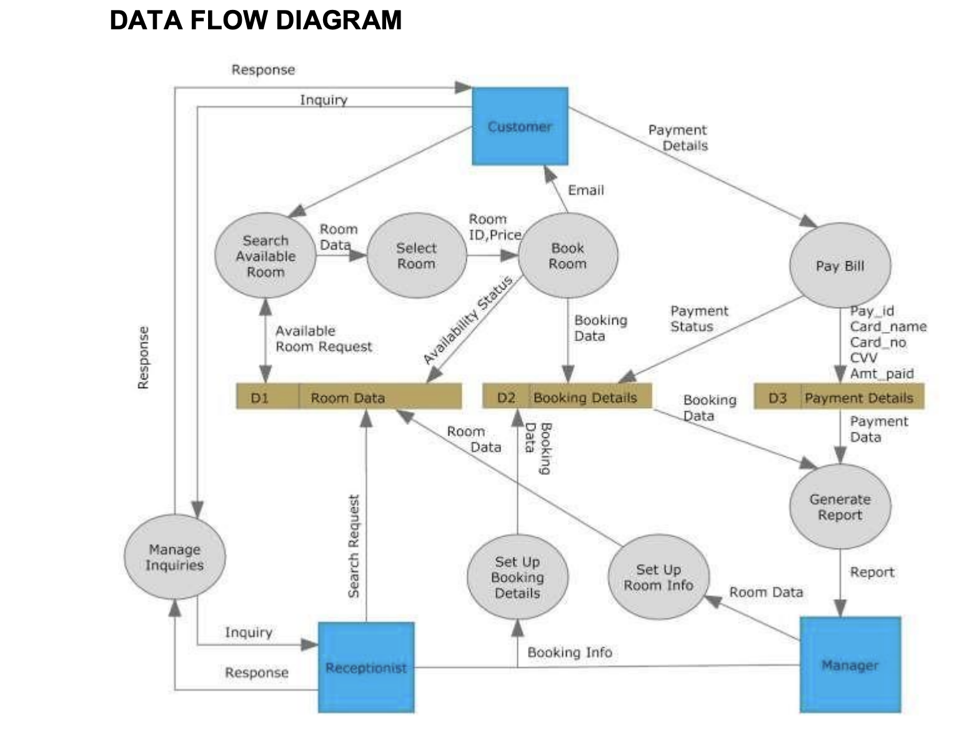

|  |  |  |  |  |
| --- | --- | --- | --- | --- |
| **Correction Parameters** | **Formative Assessment [40%]** | **Timely completion of Practical [ 40%]** | **Attendance / Learning Attitude [20%]** |  |
| **Marks Obtained** |  |  |  |